Original Post and thread here -http://forum.xda-developers.com/showthread.php?t=1199098
Here is the method xda member edgan discovered for root access. Yes, it requires the HD Station. There is currently no way around that. You have to download and extract pulse.tar in webtop. There is no other way that it will work. You can use adb or Android Terminal Emulator instead of ssh, but you are on your own. With those, expect problems with your PATH.
Images and additional notes provided by twospirits
Please donate to the original OP with the button, if you are willing. While he does not promise anything new in the future. It would just be a thank you for this hack he provided. Here is a very nice YouTube tutorial: Youtube tutorial
NOTE: All images in this step by step when clicked open up in another window in full size.
Requirements:
Item needed | Notes
HD Station | The dock is necessary because the WebTop application that is launched via dock only, provides an exploit that is used to obtain SU permissions  Webtop is needed because the Linux user that runs Webtop has access to write to /var/tmp, which is on the /osh partition and all that we use Webtop for is to get the files extracted to that partition with the proper permissions. The exploit needs to reside on the /osh partition to work properly.
Sprint Photon
HDMI cable | The one that came with the Photon or a compatible one.
Monitor or TV with open HDMI port.
Wi-Fi connection on the phone | You do need to have your phone on your local Wi-Fi on the same local Lan segment as your PC to SSH in to your phone from your pc.
Computer with network access to the phone
Steps:
Preparing your phone
1. | Install Superuser from the Market |  |  | 
2. | Install SSHDroid from the Market |  |  | 
3. | Open SSHDroid, and configure (as shown below if necessary)
Open app |  | Select Options |  |  | Make sure port is 2222 | SSHDroid is ready
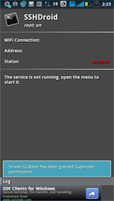 |  | 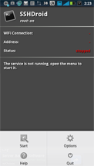 |  |  | 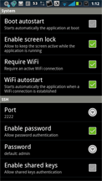 | 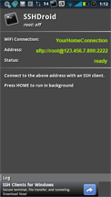
4. | Install ConnectBot from the Market |  |  | 
5. | Install or Run a SSH Client
 | For Windows, on your PC:  (in this case we use PuTTY) |  | http://bit.ly/SSH_WinPC or  ( http://the.earth.li/~sgtatham/putty/.../x86/putty.exe )
 | For Linux, in terminal window: |  | ssh -p 2222 root@ip-address-mentioned-in-SSHDroid
 | For Mac, in terminal window: |  | ssh -p 2222 root@ipaddress-mentioned-in-SSHDroid
Docking and downloading procedures
Steps 6 thru 13 needs the docking station. You connect your Photon to the docking station, perform the stepsand then do the remaining steps elsewhere. At home, if you already have the dock (instructions to the left) or at the Sprint store, (instructions to the right).
6. | Connect Photon to HD Station  (HD Station should already be connected to your TV/Monitor and your TV input to HDMI)
7. | Select WebTop (wait for it to set up & load) | 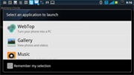
8. | Open Firefox if not already opened | 
9. | Type or Go to http://tinyurl.com/photonroot  ( http://higgs.cygnusx-1.org/~edgan/pulse.tar) | 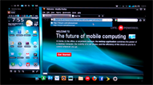
10. | Open file instead of saving | 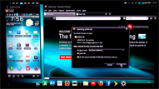
11. | Extract pulse.tar to /var/tmp | 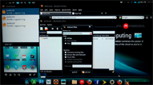
12. | Disconnect the Photon from the HD Station
Final root procedures
these last few remaining steps can be performed in the comfort of your home or outside the store.
 | Home PC instructions |  | Outside / Phone instructions
13. | Connect the Photon to your PC. | 13. | Leave the Sprint Store
14. | Run the SSH client (downloaded file from step # 5). | 14. | Run ConnectBot app on your phone
 | 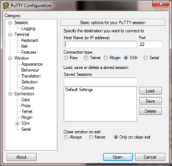 |  | 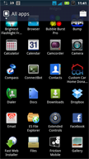
15. | Enter IP address mentioned in SSHDroid and port 2222 and connect (click Open button). | 15. | The ConnectBot app starts.
 | 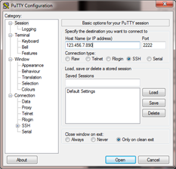 |  | 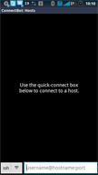
16. | You will come to the command prompt. Log in with any word for now since you are not rooted. | 16. | Click the dropdown box on the left and select local from the pop up.
 |  |  | 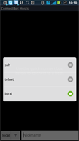
17. | If you log in incorrectly, or are rooted, or enter the commands before logging in, you will be presented with the following message. Just type anything and enter. | 17. | Click the text box to the right of the dropdown box.
 | 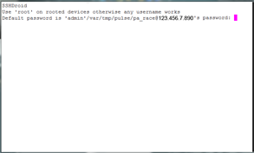 |  | 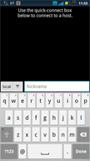
18. | Once you are logged in, you will be presented with the following prompt. | 18. | The screen refreshes
 | 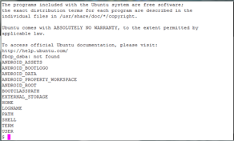 |  | 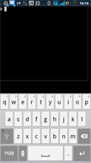
19. | Now type: /var/tmp/pulse/pa_race | 19. | Type: /var/tmp/pulse/pa_race
 | 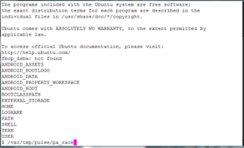 |  | 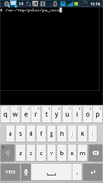
20. | (you’re now staring at a root prompt) | 20. | Persistent root now installed
 | 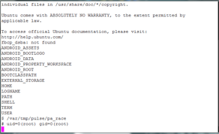 |  | 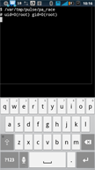
21. | Now Type: /var/tmp/pulse/install-su.sh  Superuser is now installed | 21. | Now Type: /var/tmp/pulse/install-su.sh  Superuser is now installed
 | 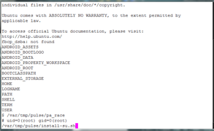 |  | 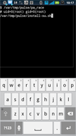
22. | Type: rm -rf /var/tmp/pulse* | 22. | Type: rm -rf /var/tmp/pulse*
 |  |  | 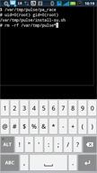
 | Evidence now deleted |  | Evidence now deleted

Run any program that needs root.
23. | Start the Superuser application  (it should tell you that it's going to update the su binary.) That’s fine. | 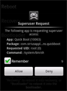
24. | Now, go install something interesting that needs root access like Titanium Backup. | 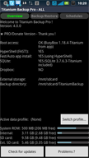
SSH links: (used as example in step 5, 14-22)
Windows: http://the.earth.li/~sgtatham/putty/.../x86/putty.exe or short url http://bit.ly/SSH_WinPC

Misc Info
Levels of hack.
1. Root (this tutorial)
2. Init aka 2nd-init
3. 2nd-boot, would be a lot of work. Custom bootloader
4. Unlocked Bootloader, (the Atrix is here)
5. Nvflash, on tegra2 based phones, and requires the SBK on retails phones
Q & A
Q: Once the phone is rooted, how do we UN-root? In case anything I do as a result of the root bricks the phone or messes something up. I’d want to know how to return the phone to stock.
A: Unrooting is just deleting the /system/bin/su file and uninstalling the Superuser application. Nothing else is altered.

